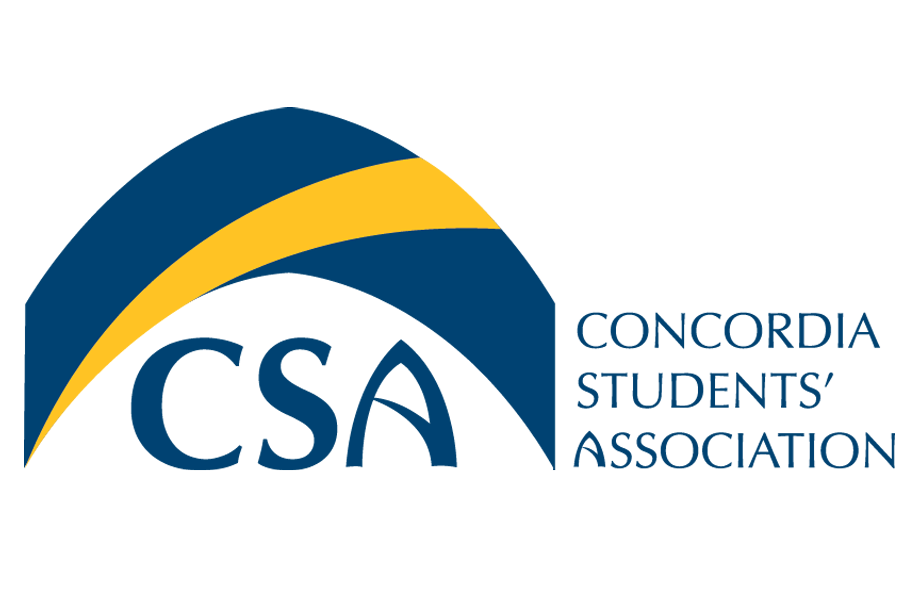
Concordia Students’ Association

Executive Council Meeting Minutes

August 31st, 2015 @ 5:00 pm

- Call to order:
  - August 31st Executive Council Meeting is called to order at 5:58 p.m.

- Roll Call:
  - President Cody Weger, Vice President Finance Shannon peacocke, Vice President Internal Colton Chacalias, Vice President Marketing Madeline Ludlage, Vice President Student Life Patrick McGinley, Executive Director Meagan Strachan, Dean of Students Barbara Van Ingen.

- Absent:
- Approval of Agenda:
  - MOTION: To approve the August 31^{st,} 2015 Executive Council Agenda. Moved by VP Marketing Ludlage, seconded by VP Student Life McGinley. MOTION CARRIED.

- Approval of Minutes:
  - MOTION: To approve the August 24th, 2015 Executive Council minutes as presented. Moved by VP Marketing Ludlage, seconded by Vp Student Life McGinley. MOTION CARRIED.

- August 24th, 2015 Action Item Review:
  - President: Send out Event Charter to all Executives- In progress
  - VP Marketing: Notify VP internal on needs for CSA booth at Club Fair-Completed
  - VP Student Life: Continue planning Beer Gardens, ensure we have a sound permit for the Beer Gardens. Ensure all event dates are correct on the Calendar-Completed
  - VP Internal: Book 2 tables, 4 chairs, projector and screen for CSA Booth at Club Fair- In progress
  - Executive Director: Pay General Councillors for summer work.- Completed

- Unfinished Business:
  - Executive Retreat: Currently looking at other locations for executive retreat. Would like a location where team building activities are available. Currently looking into Prairie Gardens, 30 minutes outside of Edmonton.

  - Thuderstorm Beer Gardens & Pancake Breakfast Update: Fencing, tents, tables, chairs and porta potties have all been ordered. Volunteers for the event are in place. Currently having difficulty obtaining a sound permit, President Weger is looking into the issue further. VP Student Life McGinley will look into the possibility of a food truck close to the garden between the hours of 5 to 8 pm. In progress of ordering kegs and a sound system for the Beer gardens event. President Weger and VP Student Life McGinley will be doing a supply run for the Pancake breakfast shortly.

  - Mental Health Coordinator Update: Have extended an offer of employment to Gillian Wilson, waiting for reply to the offer. If the offer is accepted, Gillian Wilson will have a start date of September 8th, 2015.

- New Business:
  - Office Protocol: All CSA staff, Bolt staff and General Councillors will be required to sign the office protocol. The office protocol is in place to ensure professionalism in the office.

  - Presidential Search: President Krispin’s contract at Concordia University of Edmonton ends in 2017. Currently the institution is conducting focus groups to determine the most important characteristics and qualities for a new President at Concordia. The CSA will be a focus group, a meeting to participate in the Presidential search will be scheduled in September.

  - Timesheets: New Timesheets will be used beginning September 1st, 2015. All timesheets will be filled out through excel and at the end of the month they will be printed, signed and handed to the Executive Director for filing.

  - VP Internal Search: The VP Internal will be hired. Promotional material for the vacancy will be spread around the University. Executive Director Strachan will not participate in the Interview process. All applications for the VP Internal position will be due Tuesday, September 8th, 2015. President Weger, VP Finance Peacocke and Dean of Students Van Ingen will conduct interviews for the vacancy.

  - Executive Schedules: Executive Director Strachan asks that all Executive schedules are made available to students and staff. Executives will post their schedule, including available office hours on their office doors.

- Information:
  - I believe You Campaign: Campaign launched August 31st, 2015. Campaign for sexual assault awareness. Concordia is very happy to participate. Sexual Assault Edmonton will be on campus Wednesday, September 2nd, 2015 in order to promote the campaign. CSA will assist in promotions.

  - Global Ethics Day: Global Ethics day will be October 16th, 2015 on Concordia campus. The CSA will assist in promotions but is unable to assist in planning the event.

  - Volunteer List: All CSA staff must work together to find more volunteers for CSA events. Recognition for volunteers could include reference letters, or gift cards.

- Round Table:
  - VP Marketing: Orientation photos are posted on facebook and look great. Many people have liked the photos. The CSA Facebook likes have increased by 54 people over a few days.

  - VP Student Life: Has addressed concerns about Keglers in Tegler. Windows and stairs will be fenced in and carpeted ares will be roped off.

- Adjournment :
  - MOTION: To Adjourn the August 31st, 2015 Executive Council meeting at 7:02 p.m. MOTION CARRIED.

- Action Item Summary:
  - VP Marketing- Create Promotional material for VP Internal Vacancy
  - VP Internal- Make VP Marketing an administrator on the CSA Facebook, remove Mitch from the account.
  - Executives- Post schedules and available office hours on office doors
  - President- Begin Hiring process for the VP Internal
  - Executive Director- Send Timesheets to all executives
  - VP Student Life- Rent sound system and look into possibility of a food truck close to the beer gardens
  - President- Create and distribute office protocol to be signed by all staff
  - VP Finance- Schedule time for Focus group for the Presidential Search
  - Executive Director- Add Tegler map to event charter.

