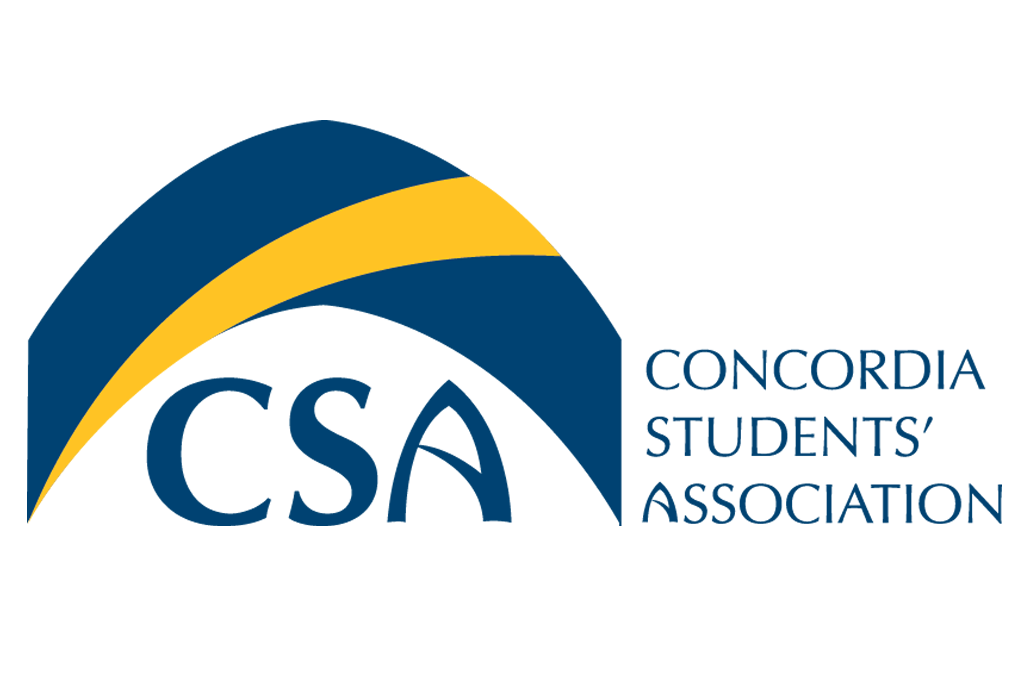
Concordia Students’ Association

Executive Council Meeting Minutes

January 28, 2016 @ 10:00 A.M.

- Call to order: January 28, 2016 Executive Council meeting called to order at 10:03 AM.

- Roll Call: Cody Weger-President, Shannon Peacocke, VP Finance, Kelsea Gillespie- VP Internal, Madeline Ludlage- VP Marketing, Patrick McGinley- VP Student Life, Meagan Strachan- Executive Director.

- Action Item Summary:

- Approval of Agenda:
  - MOTION: To approve the January 28, 2016 Executive Council agenda as presented. Moved by VP Finance Peacocke, seconded by VP Internal Gillespie. MOTION CARRIED.

- Approval of Minutes:
  - MOTION: To approve the January 21, 2016 Executive Council Meeting Minutes. Moved by VP Internal Gillespie, seconded by VP Finance Peacocke. MOTION CARRIED.

- Unfinished Business
  - Mental Health Update: Yoga to take place on Friday. CSA will have 2 tables at the wellness summit on January 30, 2016. VP Marketing will bring decorations and table cloth for the 2 tables. CSA mental health banner will be brought along with tea bags with gratitude stickers, markers and & board for gratitude project as well as the completed CSA gratitude project.
  - Nomination Package: Nomination package is nearly finished. Potential candidates will have discussion with the Executive Director prior to picking up packages.
  - Club & Union Retreat Action Items: Students who attended the second retreat had very similar opinions to those who attended the first retreat. President & Richard Currie to look into CSA Debit system. President to look into print cards for clubs. VP Internal to look into the cost of locker space for clubs. VP Marketing to create a calendar for the CSA website and all executives to schedule a time to clean out the back storage room.
  - Tropical Kegler: Was a very well planned and implemented event. The decorations looked great. The number of volunteers helped the event run very smoothly.

- New Business:
  - Bylaw Town hall: President Weger will give description of the bylaws. Screen advertising bylaw town hall will be set up in Tegler and the bylaw presentation will be set to occur in a separate room to limit background noise. President Weger to send out doodle poll for town hall dates.
  - CSA Olympics: Signups will begin the first week of February. The Monday & Friday of harry potter week at grand hall will be set up in Tegler. Wednesday will be butter beer flip cup & an option to play quidditch. Friday will be the grad fiest, potion making, wand making and photo booth. Tuesday & Thursday will be the riddle, stone & horcrux findings. VP marketing will create a program for the week’s events.
  - Spiritual Life week: VP Student Life sent out an email listing all events to occur over spiritual life week. CSA will be hosting sandwich making for the homeless on the Wednesday of spiritual life week (February 3, 2016).
  - EC Retreat: Executive Director Strachan to send out link to a house found online that will accommodate up to 11 people for the retreat.
  - Office Renovations: President to email Bob Thomson to ask about carpet & prices. President to also ask if painting the offices is a possibility over the summer.
    - MOTION To go in camera at 10:44 AM. Moved by VP Student Life McGinley, seconded by VP Internal Gillespie. MOTION CARRIED.
    - MOTION: To move out of camera at 10:48 AM. Moved by VP Internal Gillespie, seconded by VP Student Life McGinley. MOTION CARRIED.

- Information:
  - Timesheet due (January 28th, 2016 @ 10:00 am): Please print out and give timesheets to VP Finance. EC reports are due by February 8, 2016.

- Round Table:
  - VP Marketing: Created brochure for mental health summit and it looks great. Spiritual Life poster has been created & election information cards will be in today by noon.
  - Executive Director: Budget work will begin on Monday. Will figure out if mittens can go into the bookstore to be sold.
  - VP Finance: CSA was charged for the second bus at the pub-crawl. $50.00 was taken off invoice because the bus was late.
  - VP Internal: CCC will be doing a flower market February 3, 2016, CMC Conference is February 6, 2016. Model UN will be doing a bake sale February 12, 2016, & ESU will be likely hosting a bakesale over science week in the Education building.
  - President: Tueday from 3:30 PM to 5:30 PM will be storage room clean up.

- Adjournment :
  - MOTION: To adjourn the Executive Council meeting at 11:03 AM. Moved by VP Internal Gillespie, seconded by VP Student Life McGinley. MOTION CARRIED.

ACTION ITEM SUMMARY:
- President: Look further into debit system for CSA
- President: Look into Print Cards for Clubs
- President: Bring Fridge to CSA office.
- VP Internal: Look into cost of lockers for the Club storage (& location of lockers).
- VP Marketing: Create calendar for the CSA website.
- President: Schedule Bylaw Town hall.
- VP Marketing: Create program for Harry Potter Week.
- VP Student Life: Purchase items for sandwich making.
- Executive Director: Email link of house for EC retreat to executives.
- President: Ask about cost of new carpet in CSA offices and if we can paint.
- Executives: Give timesheets to VP Finance.
- Executive Director: Share budget recommendations to executive google docs folder.

