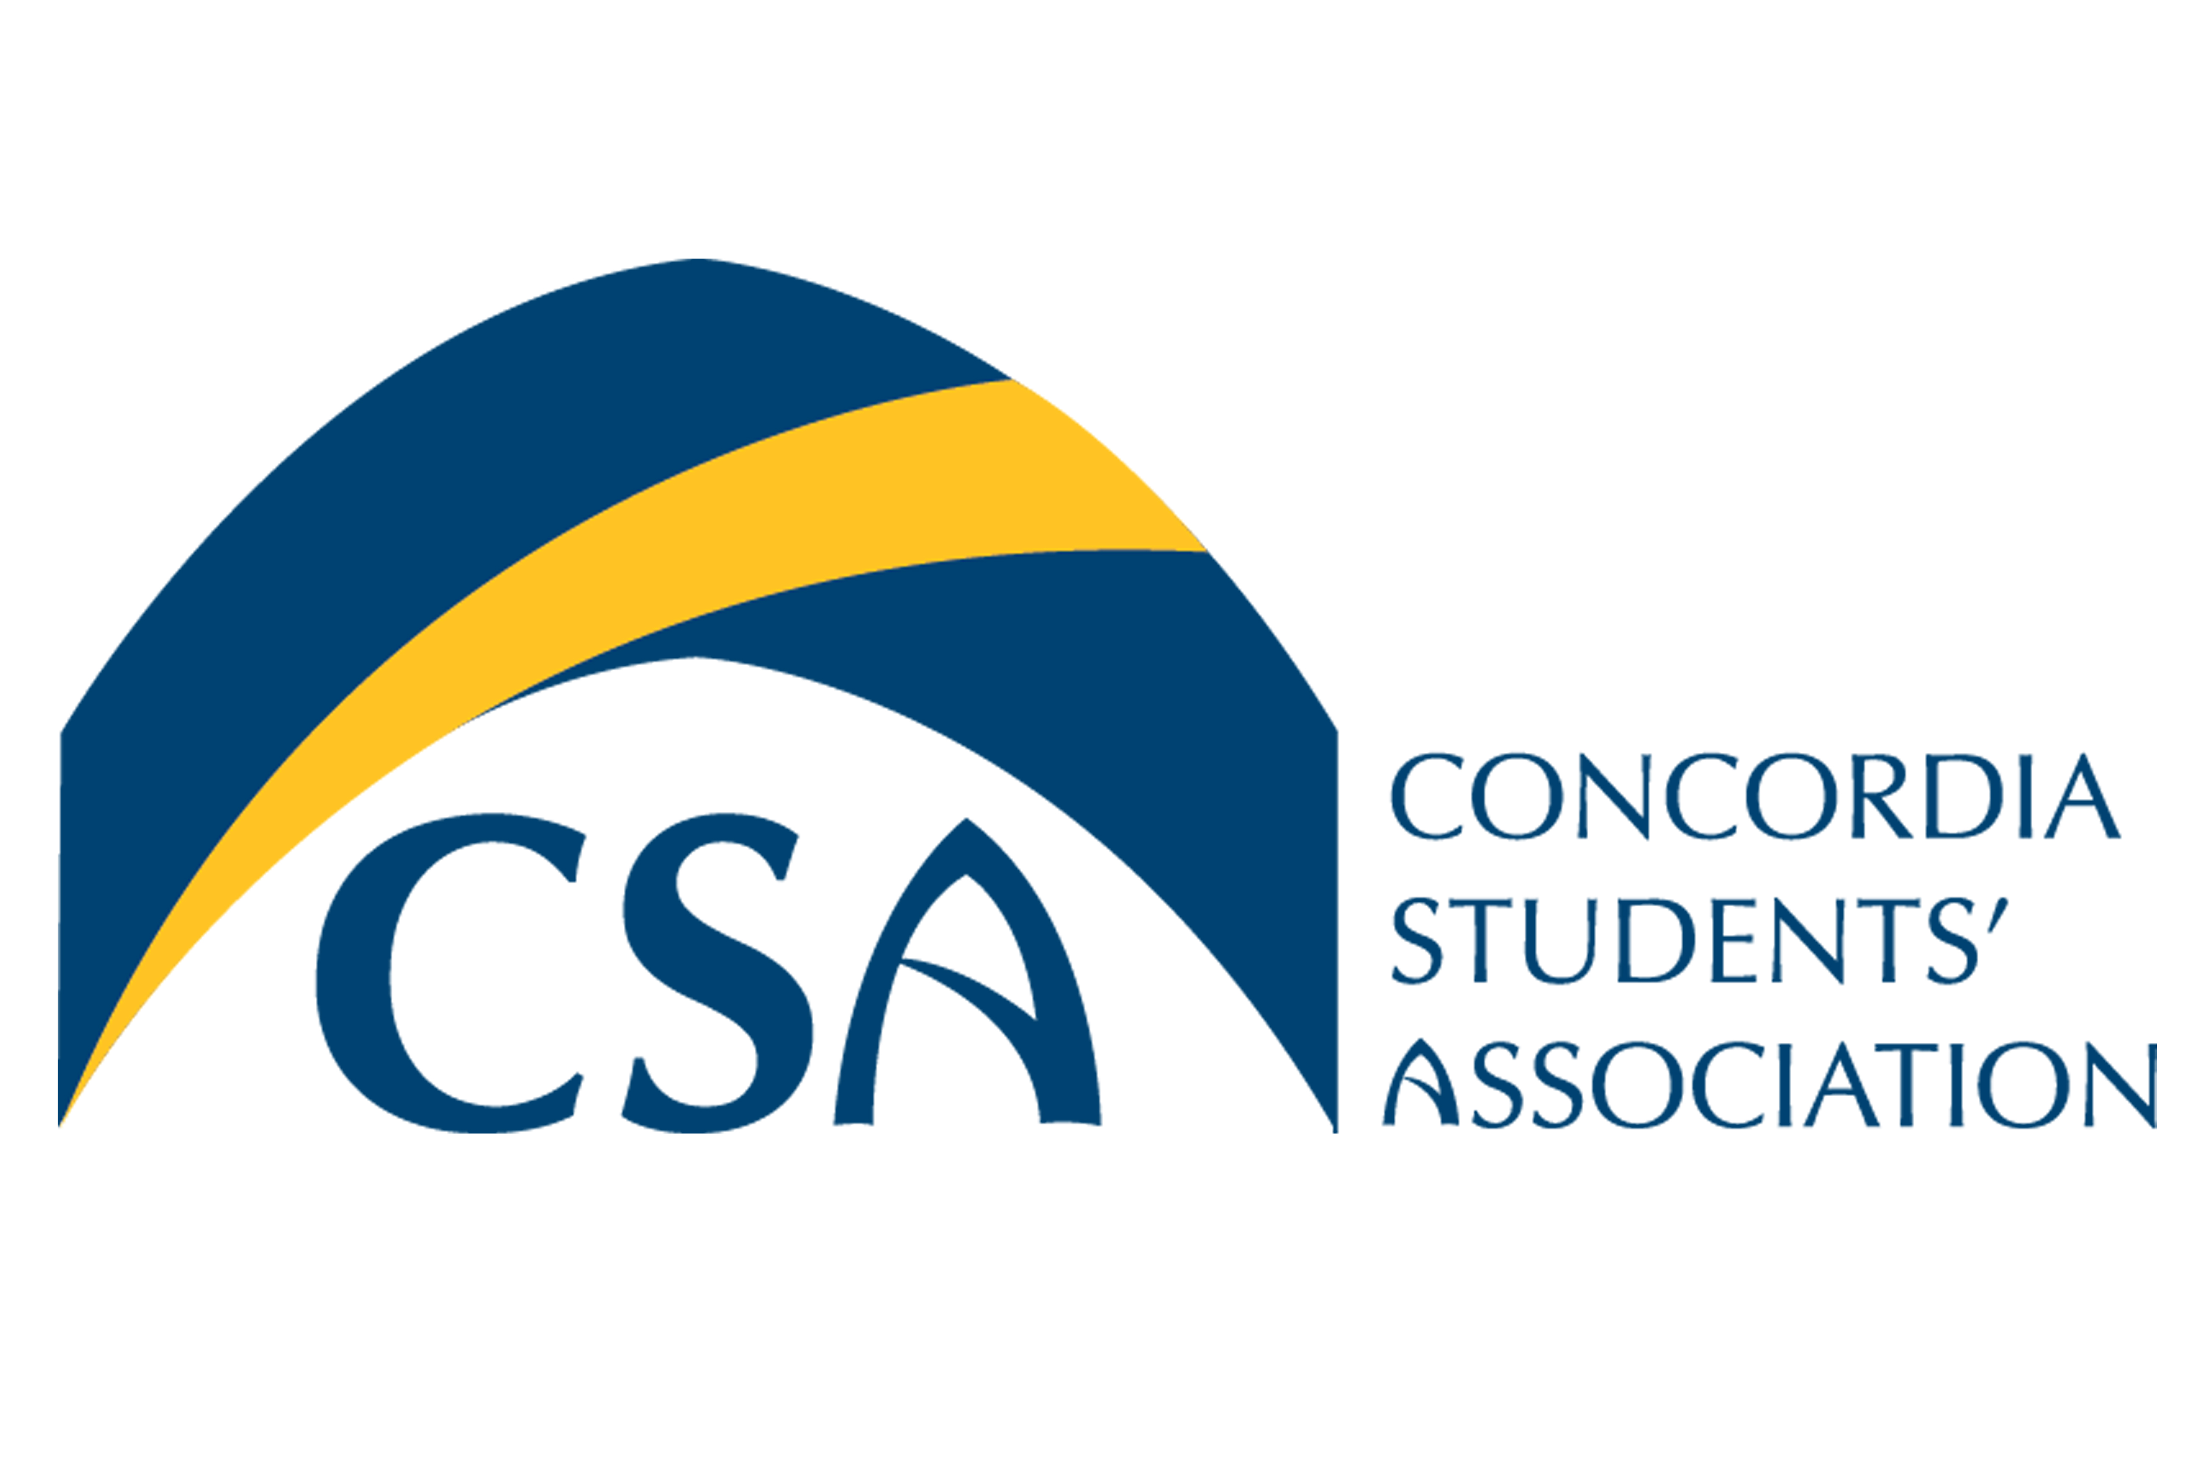
Concordia Students’ Association

Executive Council Meeting Minutes

March 3, 2016 @ 10:00 A.M.

- Call to order: March 3, 2016 Executive Council meeting called to order at 10:04 AM.

- Roll Call: Cody Weger-President, Shannon Peacocke, VP Finance, Kelsea Gillespie- VP Internal, Madeline Ludlage- VP Marketing, Patrick McGinley- VP Student Life, Meagan Strachan- Executive Director, Barb Van Ingen- Dean of Students.

- February 25, 2016 Action Item Summary:

  - VP Marketing: Advertise By law town halls on social media and website.
  - Executives: Begin preparing your positions portion of budget to be presented at March 1 meeting.
  - VP Finance: send out budget templates.
  - VP Student Life: Work on charters for volunteer appreciation event and final thunderwear.
  - Executive Director: Determine date of mental health appreciation event.
  - VP Marketing: Create marketing material and tickets for Pub Night.
  - VP Internal/President: Send old debate questions to Executive Debate.
  - Executive Director: Create structure and questions for debate.
  - Executive Director: See if The BOLT can film candidate speeches.
  - Executive Director: create CSA travel booking form based off template.
  - Executive Director: Book Midsummers night dream date.
  - Executive Director: Send out doodle to reschedule EC March 17, 2016 m

- Approval of Agenda:
  - MOTION: To approve the March 3, 2016 Executive Council agenda as amended (add 7.2. Transportation, 7.3. Mustard Seed & 8.1. ASEC.) Moved by VP Student Life McGinley, seconded by VP Internal Gillespie. MOTION CARRIED.

- Approval of Minutes:
  - MOTION: To approve the February 25, 2016 Executive Council Meeting Minutes. Moved by VP Internal Gillespie, seconded by VP Finance Peacocke. MOTION CARRIED.

- Unfinished Business
  - By-Law Town Hall: Held the first townhall on Tuesday March 1st, 2016 will be hosting the second townhall in Tegler on March 4, 2016.
  - Volunteer Appreciation: To be held March 31st, 2016. Will be a buffet style dinner for approximately 50 people. Will give out door prizes, VP Student Life work on creating an invitee list.
  - Final Thunderwear Friday: Will try to have a balloon drop & will have newly elected executives very involved in planning & implanting the event. Will purchase 1 large prize and few smaller prizes. Will need to plan a back-up weather plan.

- New Business:
  - GTC Carnival- Presentation from GTC president Josh Eastman.

  - Transportation: ASEC meeting transportation minister on Thursday March 24, 2016 from 9:00 AM to Noon. VP Student Life & VP Marketing will attend.

  - Mustard Seed: Gather a list of interested students to volunteer with the mustard seed. Will also forward mustard seed email to Brett to reach other potential volunteers.

- Information:
  - ASEC Strategic Plan: VP Internal & President to work on CSA response to the proposed ASEC structure. ASEC has approved a new mission, vision, audit & fee structure.

- Round Table:
  - President: Appont Barb as neutral chair for EC meeting while President is away for the Model UN conference. Meeting will be held on March 21, 2016 at 10:00 AM.
  - VP Marketing: Election promotions are going well. Need funds/MAC card for Pub Night event.
  - Dean of Students: ZAG has offered the CSA a free logo redesign. Would like to the CSA to encourage students to fill out the survey emailed. March 15th Concordia is hosting a Concordia Talks event focused on sexual violence on campuses. The documentary the Hunting Grounds will be shown. Friday March 18th, 2016 there will be a presentation on Fentanyl.
  - Executive Director: CSA Paint Night is tonight, liquor will be served at the event.
  - VP Finance: February month end is on track so far, reports are due for tomorrow. Timesheets are also due.
  - VP Internal: Have received some budget questions from the GTC.
  - President: Student of the year award to be presented at convocation, ACHMI survey will be sent out to students shortly.

- Adjournment :
  - MOTION: To adjourn the Executive Council meeting at 11:08 AM. Moved by VP Internal Gillespie, seconded by VP Student Life McGinley. MOTION CARRIED.

March 3, 2016 ACTION ITEM SUMMARY:
- Executive Director: Sent Mustard seed email to Brett
- VP Student Life: Create list of invitees for volunteer appreciation.
- VP Student Life: Purchase Thunderwear prizes.
- VP Internal: Submit CSA strat plan recommendations to ASEC.
- VP Finance: Decipher if funds are available for door prizes at Pub Night.
- Executives: Submit Reports and Timesheets.
- Executive Director: Send out email to all candidates about dinner.

