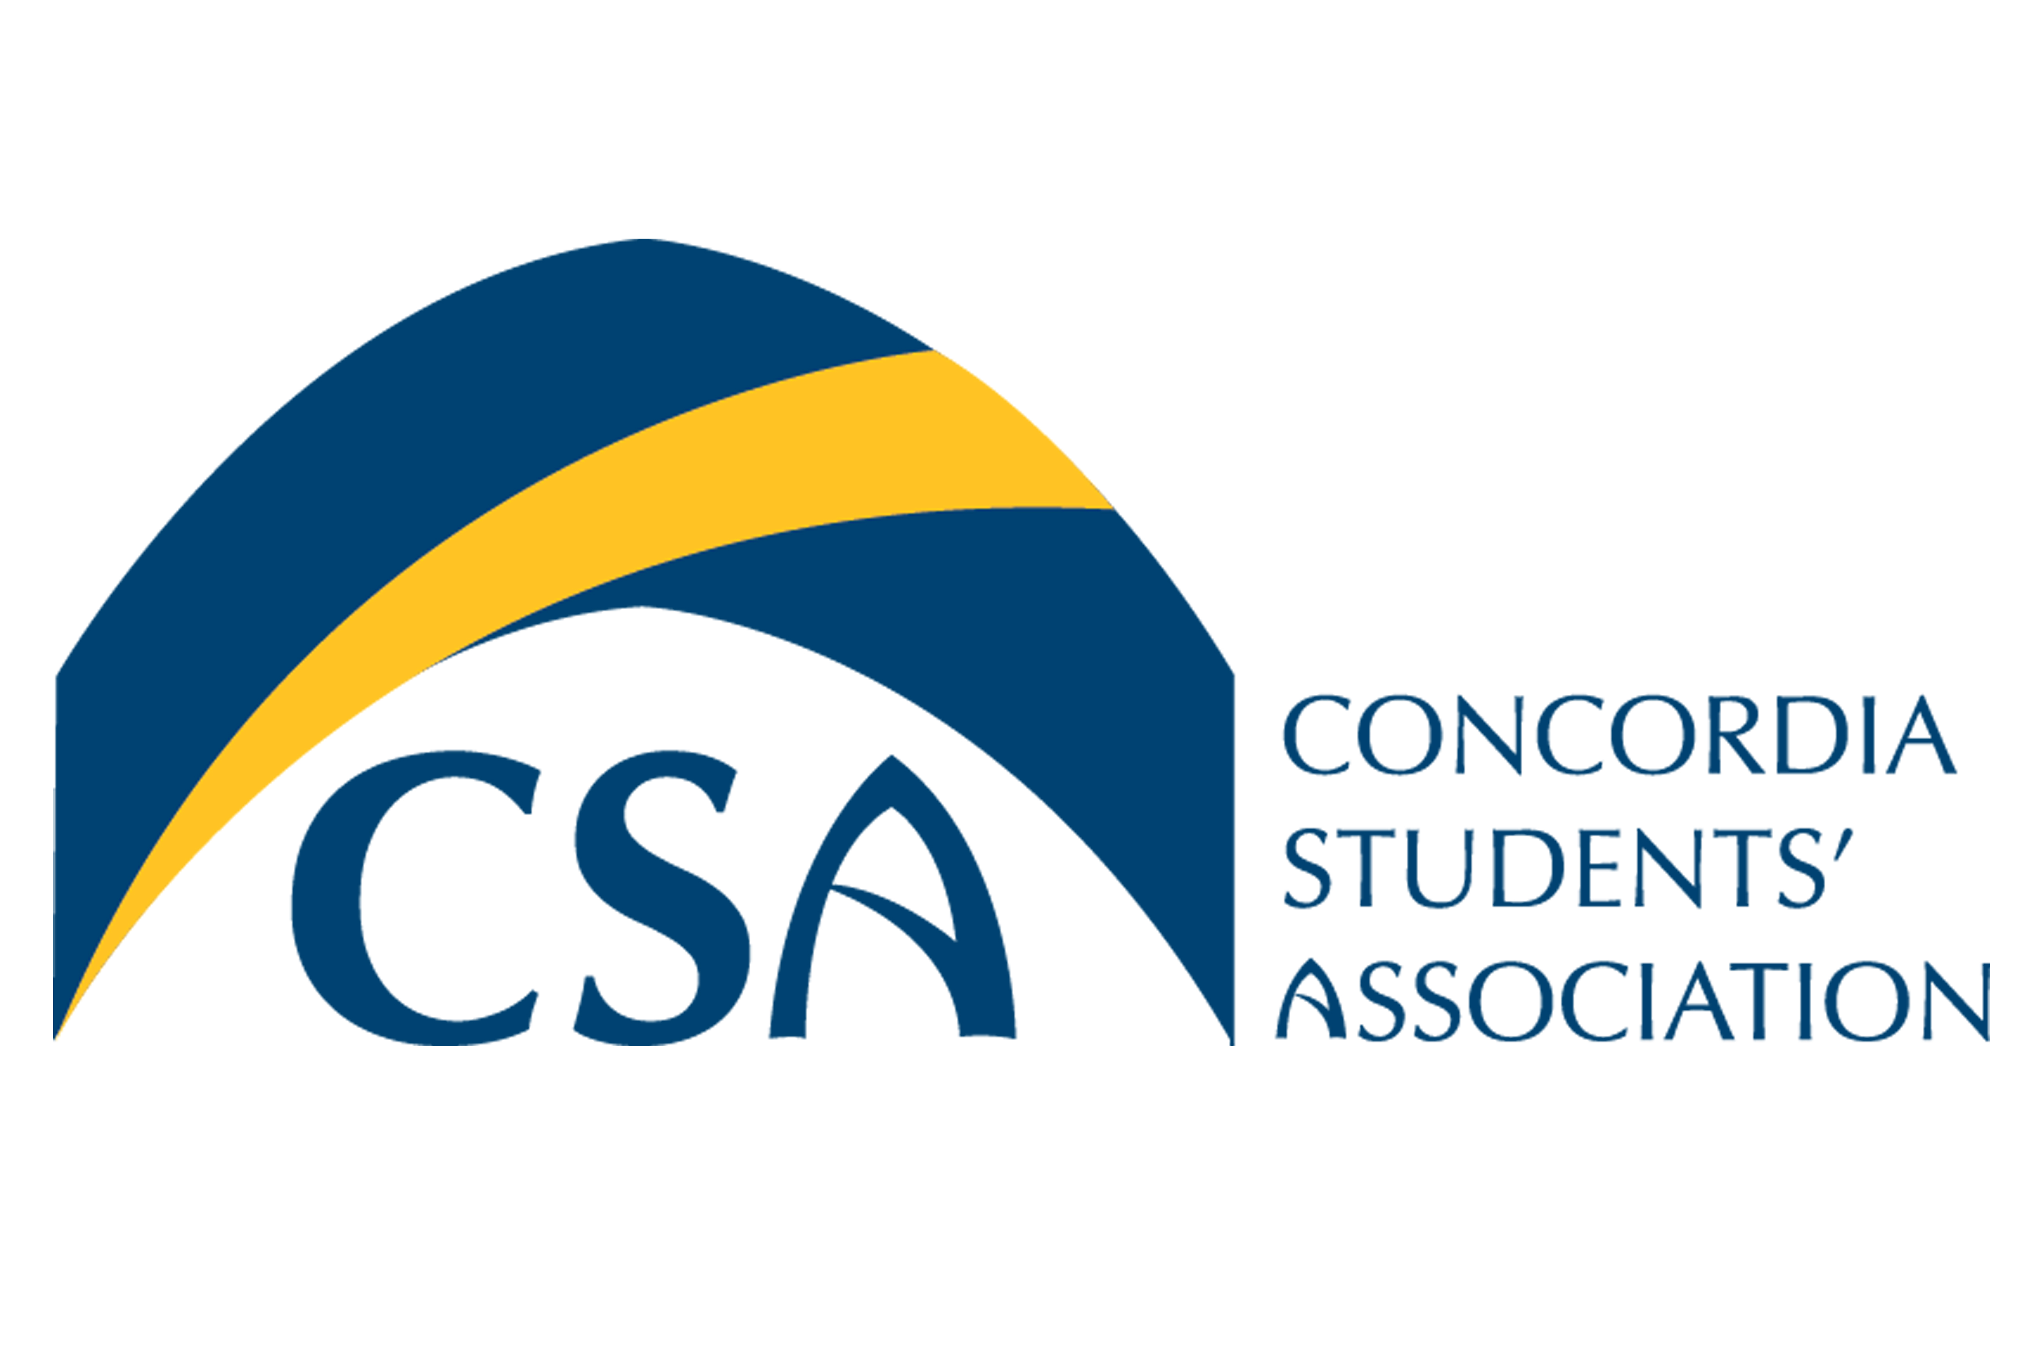
Concordia Students’ Association

Executive Council Meeting Minutes

November 30th, 2015 @ 9:00 A.M.

- Call to order: Meeting called to order at 9:06 am

- Roll Call: Cody Weger- President, Shannon Peacocke- VP Finance, Kelsea Gillespie- VP Internal, Madeline Ludlage- VP Marketing, Meagan Strachan-Executive Director, Barb Van Ingen- Dean of Students.

- Approval of Agenda:
  - MOTION: To approve the November 30th, 2015 Executive Council Agenda. Moved by VP Finance Peacocke, seconded by VP Marketing Ludlage. MOTION CARRIED.

- Approval of Minutes:
  - MOTION: To approve the November 23rd, 2015 Executive Council Minutes. Moved by VP Finance Peacocke, seconded by VP Marketing Ludlage. MOTION CARRIED.

- November 23rd, 2015 Action Item Review:
  - Executive Director: Book HA206 for winter retreat and Winter EC meeting- completed
  - President: Get liquor license for Cheers with Chancellor - completed
  - VP Student Life: Purchase liquor for cheers with the chancellor.- competed
  - VP Student Life: Put together list & dates for events next semester (including CSA Olympics)- In progress
  - President: Determine if we can use pancake griddles for possible CSA pancake breakfast- In progress
  - VP Marketing: Purchase chocolate for Tree lighting- Compelete
  - President: Contact individuals for a professional development session at the Winter EC retreat- Complete

- Unfinished Business
  - Winter Events ( Including CSA Olympics): Olympics will occur the first week of February. Students are very excited about winter semester Kegler. More information to come.

  - Winter Retreat-Professional Development: Elizabeth Smyth will give presentation on responsible governance. The presentation will be free. Winter Retreat will take place in room HA 206 on Saturday January 9th, 2016.

  - Clubs & Unions Update: GTC club is interested in planning a Shakespeare themed gala in the spring. Possibility for the CSA to partner with GTC as our formal event. S factor will take place in June. Clubs have been very active, Pro-life showed a video in Tegler, CVCS held a silent auction, Dance Club will be hosting a spaghetti dinner.

  - Mental Health Update: Please respond to Deb’s email if you intend on attending the Mental Health First Aid training. Deadline to apply for presenting at the mental health summit ( January 29th & 30th) is fast approaching.

- New Business:
  - By-Laws Revisions and Proposed Changes: Discussions occurred on the possibility of updating the positional policy for the VP Internal position. By-Law revisions will be a priority over next semester to prepare for a Bylaw referendum in March.

  - Positional Policies: VP internal Gillespie would like to review CSA positional policies to ensure they reflect each executives job responsibilities.

  - Winter Formal: Tabled to next meeting.

  - Board Update:

    - MOTION: To move in camera at 9:39 am. Moved by VP Finance Peacocke, seconded by VP Marketing Ludlage. MOTION CARRIED.
    - MOTION: to move out of camera at 9:49 am. Moved by VP Internal Gillespie, seconded by VP Marketing Ludlage. MOTION CARRIED.

  - Used Book Market/Club Fair: Club Fair to take place Janaury 12th & 13th from 10:00 am to 1:00 pm. Used book Market will run from January 6th to the 15th . Clubs retreat is TBD.

- Information:
  - ASEC Town hall: ASEC Town Hall is to take Place December 1, 2015 from 7:00 PM to 8:30 PM. Tuition meeting with CAUS will also take place December 1, 2015.

  - Christmas Hampers: 16 applications for Hampers have been received. 2/3 of applications are from individuals with children. Hampers will be handed out Thursday December 3, 2015. CSA will assist with assembly of hampers.

- Round Table:
  - VP Ludlage: Creating two brochures ( one for the CSA & one for mental health initiative). Executive pictures are framed & need to be hung up. Will bring sweaters and Jackets to the office to try on for CSA swag.
  - Dean of Students Van Ingen: Residence life position has been posted. December 2, @ 5:00 pm will be the final international café of the semester. Have worked with Gallivan to create a comprehensive health plan for Concordia exchange students.
  - VP Peacocke: Orientation T-Shirts have been ordered. Secret Santa names will be drawn tomorrow. Grant Intake date has been set. Executives, please submit any Concordia event attendance with your December reports.
  - President Weger: Thank you everyone for a great semester.

- Adjournment :
  - MOTION: To adjourn the CSA executive council meeting at 10:42 am. Moved by VP Marketing Ludlage, seconded by VP Finance Peacocke. MOTION CARRIED.
- Action Item Summary:
  - Executives: Submit executive reports.
  - VP Student Life: Submit Schedule of winter events.

