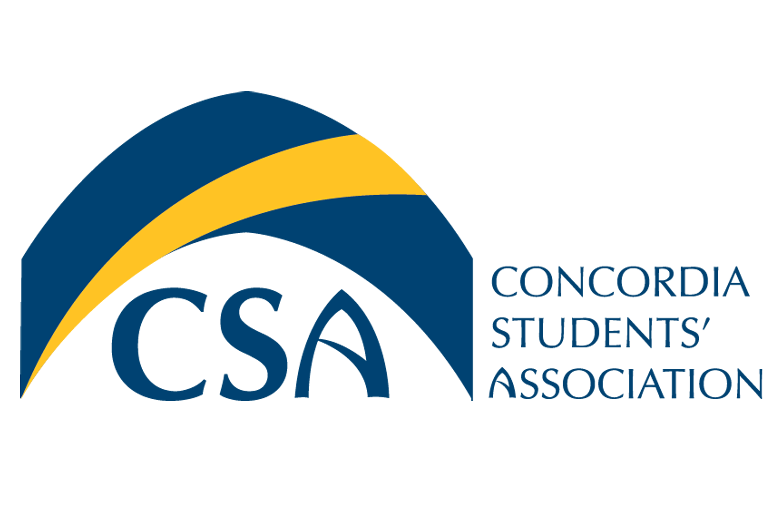
Concordia Students’ Association

Executive Council Meeting Minutes

October 5, 2015 @ 9:00 A.M.

- Call to order: This meeting is called to order at 9:05 a.m.

- Roll Call: Cody Weger- President, Shannon Peacocke- VP Finance, Kelsea Gillespie- VP Internal, Madeline Ludlage- VP Marketing, Patrick McGinley- VP Student Life, Meagan Strachan-Executive Director, Barb Van Ingen- Dean of Students.
- Absent:
- Approval of Agenda:
  - MOTION: To approve the October 5, 2015 Executive Council Meeting Agenda. Moved by VP Internal Gillespie, seconded by VP Marketing Ludlage.
  - MOTION: To amend the agenda and include item 8.2. CUCA Spooka, 8.3. Food for Thought, 9.1. BOLT Update and 9.2. Flu shots. Moved by VP Internal Gillespie, seconded by VP Marketing Ludlage. MOTION CARRIED.

  - MOTION: To approve the agenda as amended. Moved by VP Marketing Ludlage, seconded by VP Internal Gillespie. MOTION CARRIED.

- Approval of Minutes:
  - MOTION: TO approve the September 28th, 2015 Executive Council Meeting Minutes. Moved by VP Marketing Ludlage, seconded by VP Internal Gillespie. MOTION CARRIED.

- September 28th, 2015 Action Item Review:
  - VP Student Life- Recruit volunteer for the Toga Party- In progress
  - VP Finance- Get Float for Toga Party. In progress
  - VP Student Life- Order liquor, and sound equipment.-Complete
  - President- Recruit Bartenders for the Toga Party.- Complete
  - VP Marketing- Create signage for the Toga Party.- Complete
  - VP Marketing- Create labels for food bank jars.- Complete
  - VP Internal- Reach out to Alex for new Microwave.- Complete
  - President- Bring Fridge to the CSA office.- In progress
  - Executive Director- Dispose of old fridge & Microwave.- In progress
  - Executive Director- Determine if funding is available for open house.- Complete
  - Executive Director- Include “Christmas Party” in the next General Council Meeting Agenda.- Complete
  - VP Internal/VP Finance- send budgets to clubs.- Complete
  - President/Executive Director- Submit all receipts for Executive Retreat.- In progress
  - Everyone- Submit Timesheets and Reports by September 30th, 2015.- In progress
  - Executive Director- Set up account with Office Depot to order office supplies.- Complete

- Unfinished Business:
  - Toga Party Update: Kegs for the event will arrive by 6:00 pm on the day of the event. VP Student Life will pick up liquor, partitions, sound equipment, water, and cups. Volunteers will start at 4:00 PM and Bartenders/ security will arrive by 8:30 PM. President Weger will purchase liquor licence and DJ will arrive by 8:00 pm.

  - Mental Health Update: Street team has been hired. First event for the street team will be held October 14th & 15th where street team members will be handing out hot chocolate and giving out surveys to learn more about student mental health needs on campus. The next event held by the street team will be a Yoga event.

- New Business:
  - Ping Pong Ball Dispenser: Possibility to use Student Life Dispensers for Ping Pong Balls. This solution was looked into last year and found to be too expensive to get a locksmith to cut new keys and to change the coin mechanism.
  - CUCA Spooka: CUCA Spooka will take place at Santa Maria Gorreti this year. CUCA Spooka will take place on Friday October 30th, 2015 at 9:00 pm. Promotions for CUCA Spook and ticket sales will begin on October 10th, 2015 after the Toga Kegler. The CSA is currently exploring hiring our own bartenders for CUCA Spooka rather than using Santa Maria bartenders.
  - Food for Thought: Food for thought will take place in Tegler from 11:00 am to 1:00 pm. Executives will wear togas, hand out free cake and promote the upcoming Toga Kegler.

- Information:
  - Bolt Update: Weekly meetings with the Bolt Editor in Chief and VP Marketing will take place every Monday in order to keep communication lines strong.
  - Flu Shots: Flu shots will be available on campus October 26th in the Sun Room and October 27th in room S206. All staff and students are welcome to receive the shot.

- Round Table:
  - VP Marketing: Has a great street team member who is assisting the VP Marketing with posting posters. All lockers on campus have been tagged with Toga Kegler marketing.
  - Dean of Students: Talking circles related to Concordia’s Indigenous strategy are taking place. The CSA will meet on October 14th to offer input, questions will be sent out beforehand to allow time to think about responses.
  - VP Finance: Still waiting on some receipts from the Thunderstorm Beer Gardens.
  - President: 3 candidates for the Arts rep position have been interviewed. An offer has been made to Natasha Miller for the position of Arts Rep. Food bank Jars should be retrieved once per week.
  - VP Internal: Have received budgets from YEC, GTC, Pre-Optometry, Pre Health, and CCU for the upcoming grant intake.

- Adjournment :
  - MOTION: To adjourn the October 5th, 2015 Executive Council Meeting at 10:12 a.m. Moved by VP Internal Gillespie, seconded by VP Student Life McGinley. MOTION CARRIED.
- Action Item Summary:
  - Executive Director: Create SI & Foodbank page for the CSA Website.
  - President/ Executive Director: Look into “Infinite Resources” What were they used for last year?
  - VP Student Life: Pick up items for Toga Kegler Friday morning (Sound system, lights, partitions, liquor, water, cups etc.)
  - VP Marketing: Shop for Toga decorations and toga material for executives.

