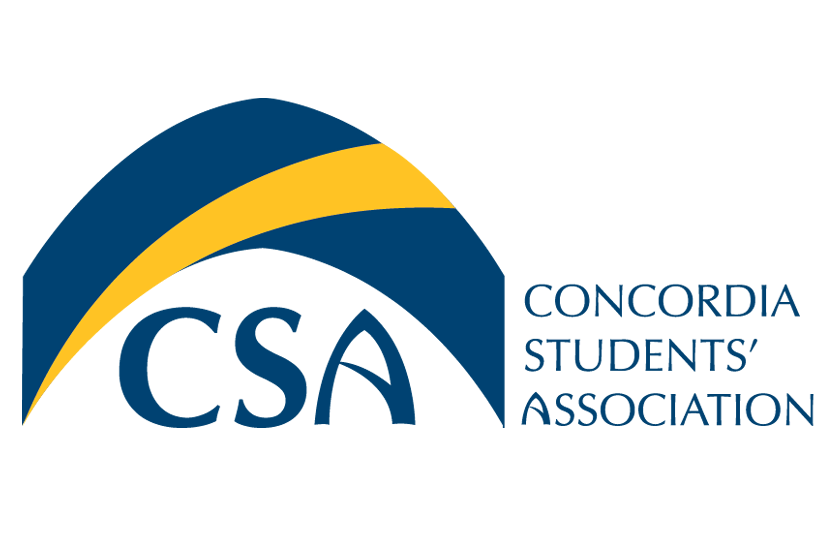
Concordia Students’ Association

Executive Council Meeting Minutes

September 21st, 2015 @ 9:00 A.M.

- Call to order: Meeting called to order at 9:12 A.M.

- Roll Call: Cody Weger-President, Shannon Peacocke- VP Finance, Kelsea Gillespie- VP Internal, Madeline Ludlage- VP Marketing, Patrick McGinley- VP Student Life, Meagan Strachan- Executive Director, Barb Van Ingen- Dean of Students.

- Absent:

- Approval of Agenda:
  - MOTION: To approve the September 21st, 2015 Executive Council Meeting Agenda. Moved by VP Internal Gillespie, seconded by VP Marketing Ludlage. MOTION CARRIED.

- Approval of Minutes:
  - MOTION: To approve the September 14th, 2015 Executive Council meeting minutes as presented. Moved by VP Finance Peacocke, seconded by VP Marketing Ludlage. MOTION CARRIED.

- September 14th, 2015 Action Item Review:
  - President: Find 2014/2015 General Council Minutes-
Completed
  - Executives: Email office hours to VP Marketing- Completed
  - Executive Director: Book ASEC conference for executives- In progress.
  - Executives: Submit a 1 hour time team building activity to Executive Director for agenda of the executive retreat- In progress
  - Executive Director: Book Executive retreat- Completed
  - VP Student Life: Find date to sell oil kings tickets for the winter semester- Completed
  - VP Finance: Inform Kelly on the CSA’s plan with Eskimo & Oil King Tickets- In Progress
  - VP Marketing: Create marketing for hiring of a General Council Arts Representative- Completed.
  - VP Student Life: Reach out to convocation committee- Completed.
- Unfinished Business:
  - Mental Health Update: Interviews are being scheduled for the mental health street team. VP Finance Peacocke and President Weger will participate in the interviews. Deb Huber will have a completed plan for the year by Thursday. She will present her plan to the Executives next week during the EC meeting.
  - Bolt Payment: Unless a contract was signed by the anonymous writer last year, we are unable to pay the writer retroactively for articles from the last fiscal year. If a contract is signed the anonymous writer may be paid for the current years’ articles.

  - Executive Retreat: Retreat is booked. CSA Executives and Executive Director will be going to Calgary over the weekend of September 25th, 2015. The agenda for the weekend consists of goal setting, determining direction for a CSA strategic plan and team building activities.

  - General Council Seat: So far there are 3 applicants for the position of General Councillor, Art Representative. President Weger, VP Internal Gillespie and General Councillor Maschmeyer will conduct interviews to fill the position.

- New Business:
  - Food Bank Donations: Donation cans will be distributed around the campus in order to collect donations for the Concordia Food Bank. The bolt will also run a food drive in order to collect more food items for the food bank. It is projected the food drive will run in October, the week before thanksgiving. The bolt will be able to advertise the drive in their next issue.

  - Float: $10.00 from petty cash will be taken to fix the float shortage from the Swag sales.

  - Convocation: The CSA has been asked for $32,000 for the convocation reception. Currently the CSA does not have $32,000 budgeted and therefore, must find a way to reduce costs or find sponsorship for the Convocation reception.

  - Student Health 101: Student health 101 was slightly more than budgeted due to the high US exchange rate.

    - MOTION: To approve $5029.88 for student health 101. Moved by VP Finance Peacocke, seconded by VP Marketing Ludlage. MOTION CARRIED.

  - Oil Kings: The CSA will promote an oil kings game for March 3rd, 2015. The goal is to have 50 Concordia students attend the game.

  - Toga Party: Toga part is nearly planned, must give Colette event charter and risk assessment. Volunteer coordination is also needed.

  - Policies: Executives must meet to review CSA policies as per policy. A 2 hour meeting will be scheduled in October to review and recommend any changes to the Policy and Governance Committee.

  - Mission + Vision: A review of our mission and vision may be necessary, this could occur while working on our strategic plan. Executives should be introduced to the mission and vision of the CSA shortly after they are elected.

- Information:
- Round Table:
  - VP Internal Gillespie: Revamped club filing and invited all Clubs and Unions to visit on Friday. Would like a key to lock up files in the office.
  - Dean of Students Van Ingen: Will be attending a webinar regarding stats of Sexual Assault on Post-Secondary campuses. Concordia has developed a sexual harassment policy.
  - Executive Director Strachan: Scout cards are selling well at the bookstore. We’ve sold 40 so far.
  - VP Finance Peacocke: Needs all receipts for Pancake Breakfast and Thunderstorm Beer Gardens. Presidential search focus group meeting occurred last week, if you were unable to attend please email VP Finance any input or feedback. The Institution is still looking for more student feedback. Pre-Optometry Club has submitted a budget for the new club grant intake. Payroll for Bolt editors and writers will be completed this week.
  - VP Marketing Ludlage: Website is updated and looking great. Will be ordering winter swag next week. Toga Party and Arts Representative promotional material has been distributed across campus.
  - President Weger: Executives must complete a report to be added to the next General Council meeting. Please have September reports submitted by September 30th, 2015.

- Adjournment :
  - MOTION: To adjourn the September 21st Executive Council meeting at 10:46 A.M. Moved by VP Internal Gillespie, seconded by VP Marketing Ludlage. MOTION CARRIED.

- Action Item Summary:
  - Executives: Submit one hour team building activity to Executive Director for the Executive Retreat
  - VP Finance: Balance SWAG float.
  - President/VP Finance: Search for Anonymous writer contract.
  - President: Schedule interviews for Arts Rep position.
  - VP Internal: Purchase cans for food bank donations.
  - Executive Director: Reach out to Food Bank for boxes for the Bolts’ food drive.
  - VP Marketing: Create labels for food bank jars.
  - President/VP Marketing: Alert BOLT Editor in chief of timing for the CSA Food Drive.
  - President/VP Student Life: Set up a meeting with Susan to discuss funding of Convocation Reception.
  - Dean of Students: Talk to President Krispin regarding CSA involvement in funding the Convocation Reception.
  - President: Confirm price of Oil King tickets.
  - VP Student Life: Send Event Charter and risk assessment for Toga Party to Collette.
  - President: Reach out to security regarding the number of guards needed for the Toga Party.
  - President: Email current bylaws to VP Marketing Madeline.

